|  |  |
| --- | --- |
|  | **VIỆN ĐÀO TẠO QUỐC TẾ FPT**  **LẬP TRÌNH VIÊN QUỐC TẾ** **FPT - APTECH** |

**Centre Name: ACE-HCMC-2-FPT.**

**Address: 590 Cach Mang Thang 8, District 3, Ho Chi Minh City, Viet Nam.**

**Symphony Limited**

**Design Document**

|  |  |  |
| --- | --- | --- |
| **Supervisor** | Ms.Nguyễn Kim Thuần | |
| **Semester** | 3 | |
| **Batch** | T1.2109.E0 | |
| **Group** | 3 | |
| **Serial No.** | **Enrollment Number** | **Student Name** |
| 1. | Student1319917 | Đào Bùi Quang Hưng |
| 2. | Student1331713 | Mai Quốc Tuấn |
| 3. | Student1320255 | Lê Quốc Trung |

**SYMPHONY LIMITED**

Table of Contents

REVIEW 1 4

I. ACKNOWLEDGEMENTS: 5

II. PROBLEM DEFINITION: 5

III. REQUIREMENT SPECIFICATION: 6

1. Functional Requirement Specifications 6

2. Non-Functional requirement specifications 7

3. System requirement specifications 7

Task Sheet Review 1 9

REVIEW 2 10

I. ARCHITECTURE AND DESIGN OF THE PROJECT: 11

II. ALGORITHM AND DATA FLOWCHART: 11

1. Symbols generates: 11

2. Student Sitemap 12

3. Admin Sitemap 13

4. Login Process (Admin) 13

5. Logout Process 14

III. USE CASE DIAGRAM: 14

1. Student 14

2. Admin 14

IV. ENTITY – RELATIONSHIP DIAGRAMS: 16

Task Sheet Review 2 18

REVIEW 3 19

I. Site Map 20

1. User Site Map 20

2. Admin Site Map 20

II. Database Design (SQL Server) 21

III. GUI Design 21

1. User 21

2. Admin 23

Task Sheet Review 3 27

# REVIEW 1

## ACKNOWLEDGEMENTS:

We would like to express our special thanks to our instructor, Mr. Nguyen Kim Thuan at the Aptech Computer Education HCMC for his able guidance and support in completing our project. We would also like to extend our gratitude to the staff at the Aptech HCMC office for providing us with all the facilities that were required.

Next, we appreciate the efforts of our team members who have collaborated in this project. Despite the challenges that we had faced, we tried our hardest to overcome them and managed to further improve our teamwork skills.

And Lastly, we wish to express our gratitude to the e-Project Team at the Head Office in India for providing a great opportunity to apply what we have learned into reality and acquire essential experiences for our future.

## PROBLEM DEFINITION:

Currently, there are many different training centers and institutes for information technology so Symphony Ltd. is private institute, which generally conducts the classes and training materials for the various certifications that are related to IT and Software industries like networking related, Java related, database related like for SQL Servers, oracle, etc. They are one of the famous institutions which have spread in to various branches situated at different location in the state. They provide various resources like the preparation materials, lab facilities based on the subject, extra lab hours or sessions (offered after the course duration), 24 hours faculty guidance is provided for the lab sessions, assignments, Library facilities, etc.

**ADMIN:**

ADMIN will login and have a master management access like ADMIN can update information of users, add or delete the course and answer user questions

**Advantages:**

Symphony Ltd has good facilities, before enrolling in the course, all applicants must take an entrance exam to check their knowledge in order to be segregated into classes corresponding to their knowledge level.

**Disadvantages:**

Enrollees must pay the course fee at least 1 day in advance from the start of the course and have to pay extra if they want to use the lab sessions.

## REQUIREMENT SPECIFICATION:

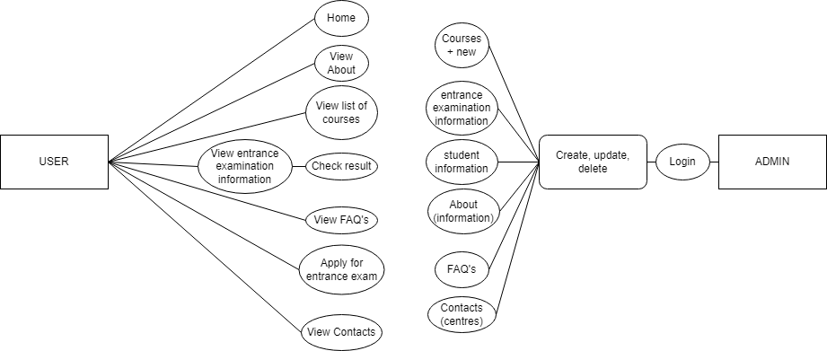

### Functional Requirement Specifications

**1.1 Home page**

R1: Contain menu to link to single page

     R2: Display information about the institution like introduction, course  
            that the institution offered.

**1.2. About us**

     R1: Display information about the institution

**1.3. List course**

     R1: Display courses offered along with topics covered

**1.4. The entrance examination**

     R1: Display details of upcoming entrance examinations

     R2: Enter roll number to see personal results, class, fees of the class and last day of payment

**1.5. FAQ’s**

     R1: Display all frequently asked questions

**1.6. Contact us**

     R1: Display information about the centres

**1.7. Admin login**

     R1: Enter admin’s email and password to login

**1.8. Admin dashboard**

R1:Create, update, delete courses (including new courses).

      R2: Enter the student’s details like the roll number, name, the marks and the class.

      R3: Enter or update the information about the institution.

      R4: Enter, update, or delete the FAQ’s.

      R5: Enter, update, or delete the Entrance Examination Information.

      R6: Enter, update, or delete the list of the centres of different branches.

### Non-Functional requirement specifications

2.1. Good User Interface, User Experience.

2.2. Clean code, project.

2.3. Try hard to improve the performance.

2.4. Have this website able to run on all browsers.

2.5. Responsive on mobile, tablet, desktop.

2.6. Try to limit bugs on this website.

### System requirement specifications

#### *3.1 Server requirements:*

* Hardware:

|  |  |
| --- | --- |
| Component | Requirement |
| CPU | Processor type:  Pentium IV-compatible processor or faster  Processor speed:  Recommended: 3.3 GHz or faster |
| OS | Microsoft Windows 8.1 or higher with IIS |
| Memory (RAM) | RAM:  Minimum: 2 GB  Recommended: 4 GB or more |
| Hard Drive | Free space:  Minimum: 200 MB  Recommended: 50 GB or more  Maximum: Operating system maximum |

* Software:

|  |  |
| --- | --- |
| Component | Requirement |
| Web App | Version .NET Core 6.0 |
| RDBMS | SQL Server |

3.2 Client Requirement:

* Hardware:

|  |  |
| --- | --- |
| Component | Requirement |
| CPU | Processor type:  Pentium III-compatible processor or faster  Processor speed:  Recommended: 3.3 GHz or faster |
| OS | All OS(Window ,Linux ,Android ,Mac OS …) |
| Memory (RAM) | RAM:  Minimum: 512 MB  Recommended: 4 GB or more  Maximum: Operating system maximum |
| Hard Drive | Free space:  Minimum: 10 MB |

* Software:

|  |  |
| --- | --- |
| Component | Requirement |
| Web Browser | Microsoft Edge, Mozilla Firefox, Chrome |

#### *3.3. Development Software:*

* SQL Server.
* Microsoft Visual Studio.

#### *3.4 Technology:*

* ASP.Net core 6.0

# Task Sheet Review 1

|  |  |  |  |  |  |
| --- | --- | --- | --- | --- | --- |
| **Members Group** | | **Date Preparation Of Activity Plan** | | | |
| **No** | **Name** | **Description Task** | **Start Date** | **End Date** | **Status** |
| 1 | Đào Bùi Quang Hưng | Review 01 | 04/12/2022 | 07/12/2022 | Completed |
| 2 | Mai Quốc Tuấn | Review 01 | 04/12/2022 | 07/12/2022 | Completed |
| 3 | Lê Quốc Trung | Review 01 | 04/12/2022 | 07/12/2022 | Completed |
|  | | | | | |
| **Teacher** | | | **Team Leader** | | |
|  | | |  | | |
| **Nguyễn Kim Thuần** | | | **Đào Bùi Quang Hưng** | | |

# REVIEW 2

## ARCHITECTURE AND DESIGN OF THE PROJECT:

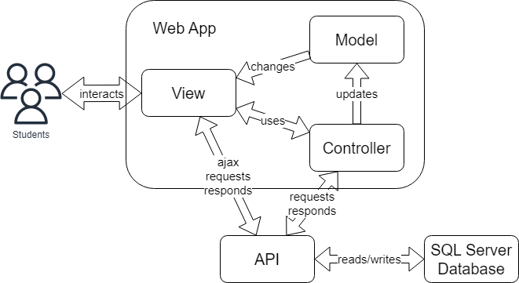

## ALGORITHM AND DATA FLOWCHART:

### Symbols generates:

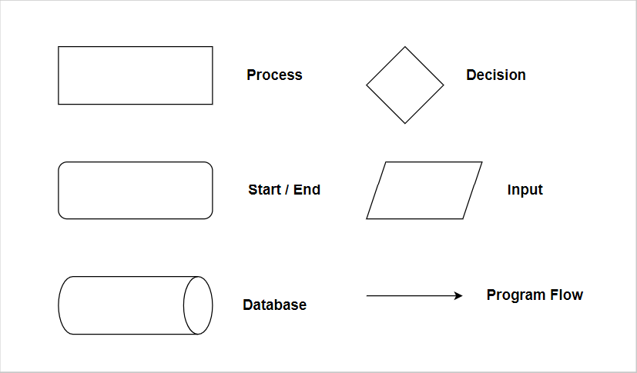

### Student Sitemap

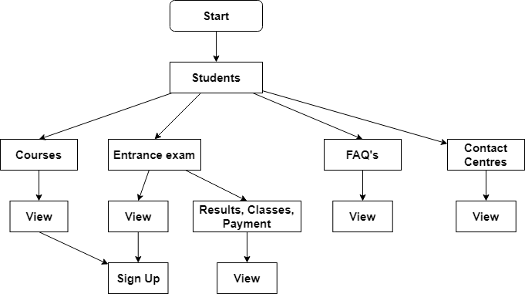

### Admin Sitemap

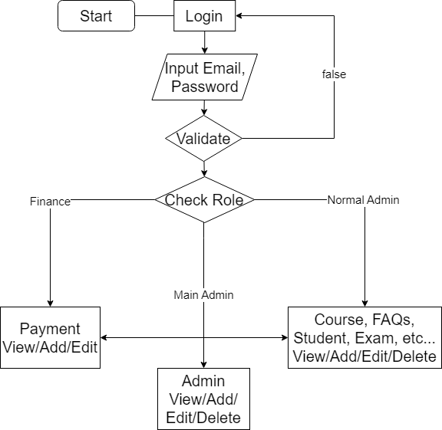

### Login Process (Admin)

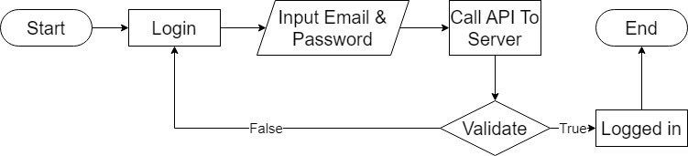

### Logout Process



## USE CASE DIAGRAM:

### Student

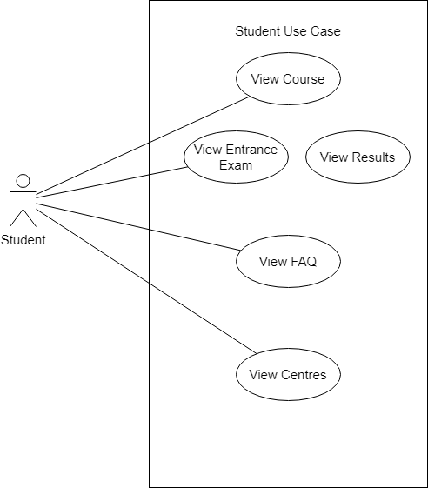

### Admin

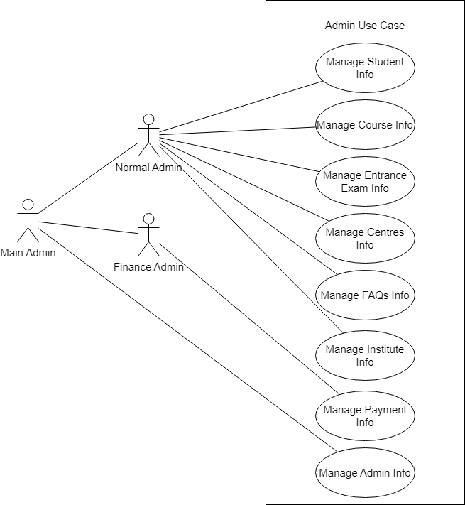

## ENTITY – RELATIONSHIP DIAGRAMS:

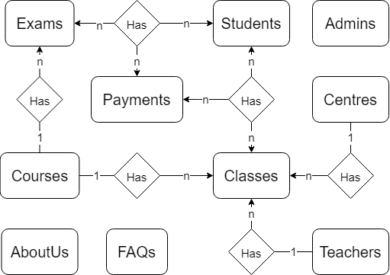

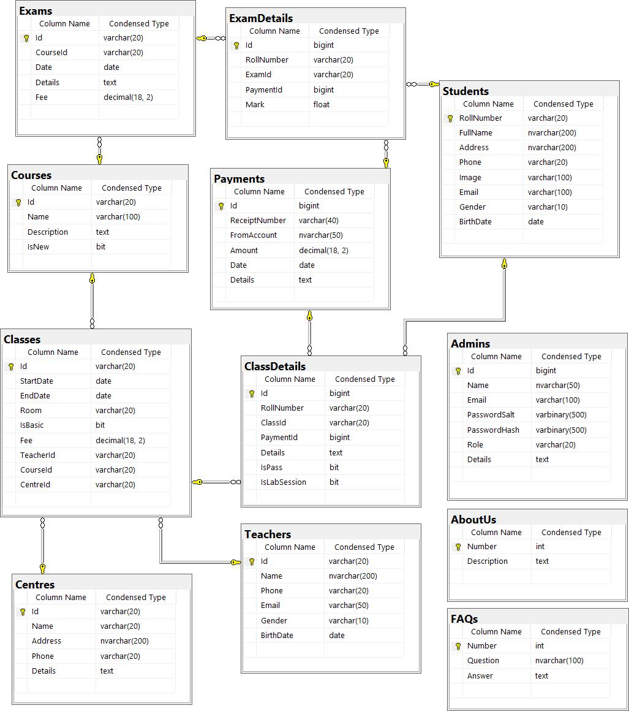

# Task Sheet Review 2

|  |  |  |  |  |  |
| --- | --- | --- | --- | --- | --- |
| **Members Group** | | **Date Preparation Of Activity Plan** | | | |
| **No** | **Name** | **Description Task** | **Start Date** | **End Date** | **Status** |
| 1 | Đào Bùi Quang Hưng | Architecture, Database | 08/12/2022 | 16/12/2022 | Completed |
| 2 | Mai Quốc Tuấn | Flowchart | 08/12/2022 | 16/12/2022 | Completed |
| 3 | Lê Quốc Trung | Use Case | 08/12/2022 | 16/12/2022 | Completed |
|  | | | | | |
| **Teacher** | | | **Team Leader** | | |
|  | | |  | | |
| **Nguyễn Kim Thuần** | | | **Đào Bùi Quang Hưng** | | |

# REVIEW 3

## Site Map

### User Site Map



### Admin Site Map

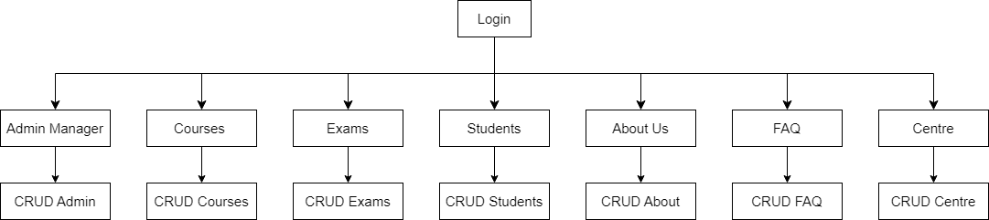

## Database Design (SQL Server)



## GUI Design

### User

* **Home Page**

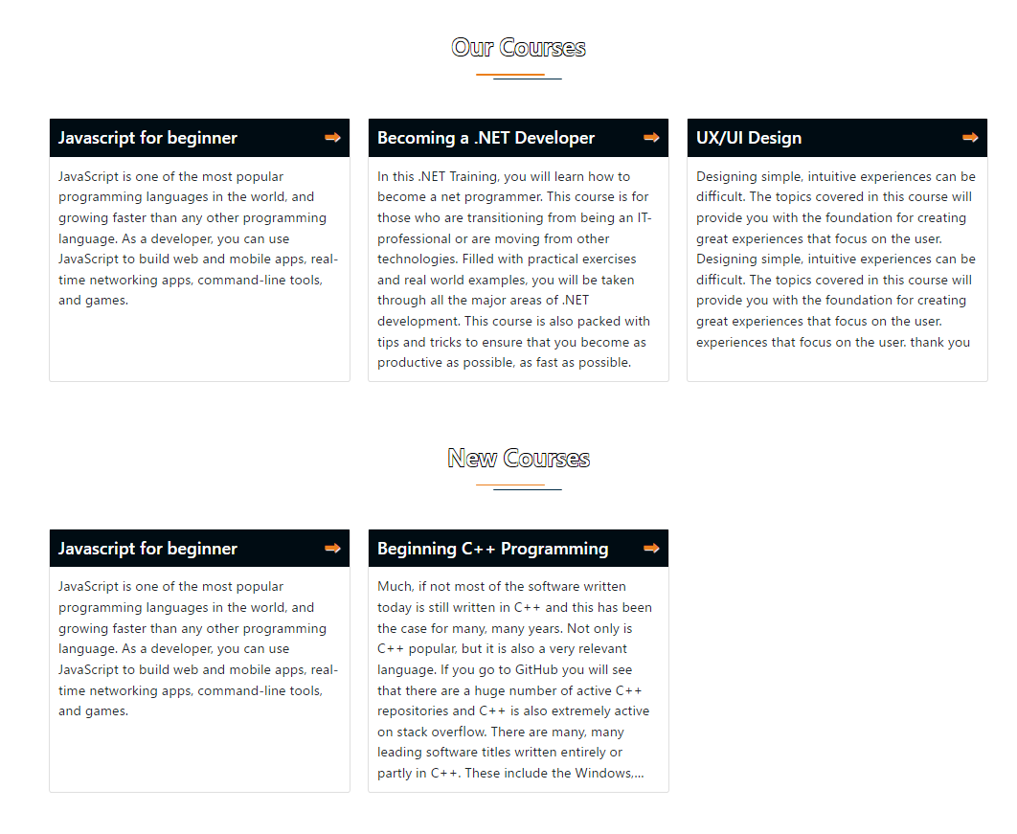



* **Purpose:** Show brief description of the institute and few courses offered, new course details, etc. are to be displayed
* **From:** Normal site URL, header link (logo)
* **To:** Link to courses
* **Description:** Data taken from course API (filtered to get new course)
* **Header**
* **Purpose:** Link to various functionalities
* **From:** Always at the top of site
* **To:** Other pages
* **Description:** Header of website
* **Footer**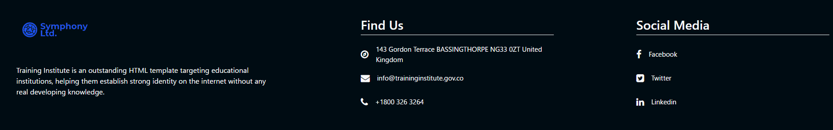
* **Purpose:** Show main contact information
* **From:** Always at the bottom of site
* **To:** Contacts information
* **Description:** Footer of website
* **About Us**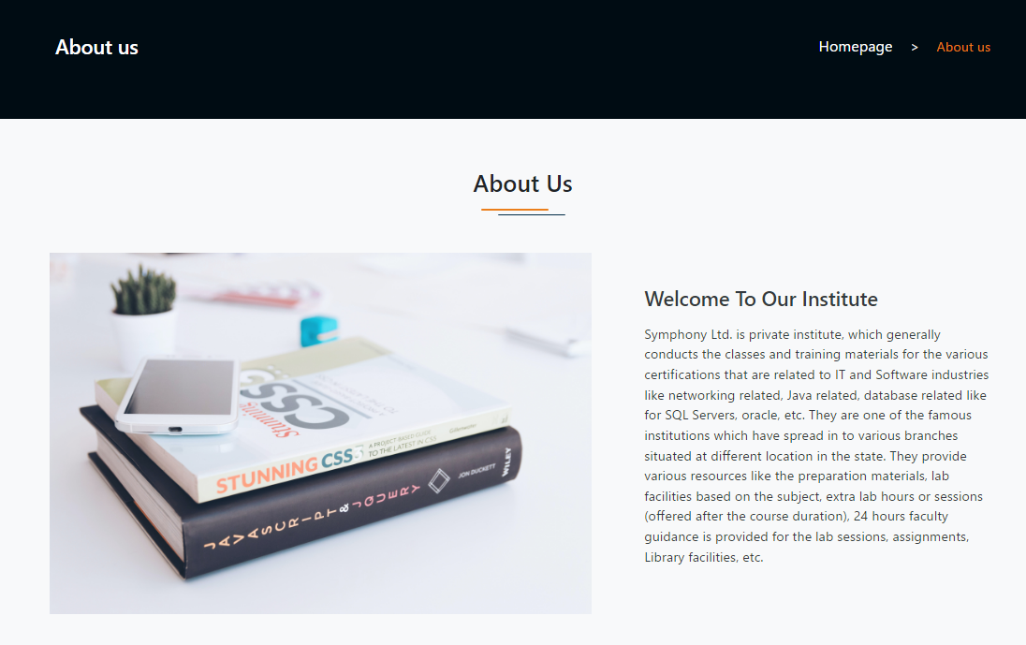
* **Purpose:** Show information about the institution
* **From:** Header link
* **Description:** Data taken from AboutUs table using API
* **Course Details**

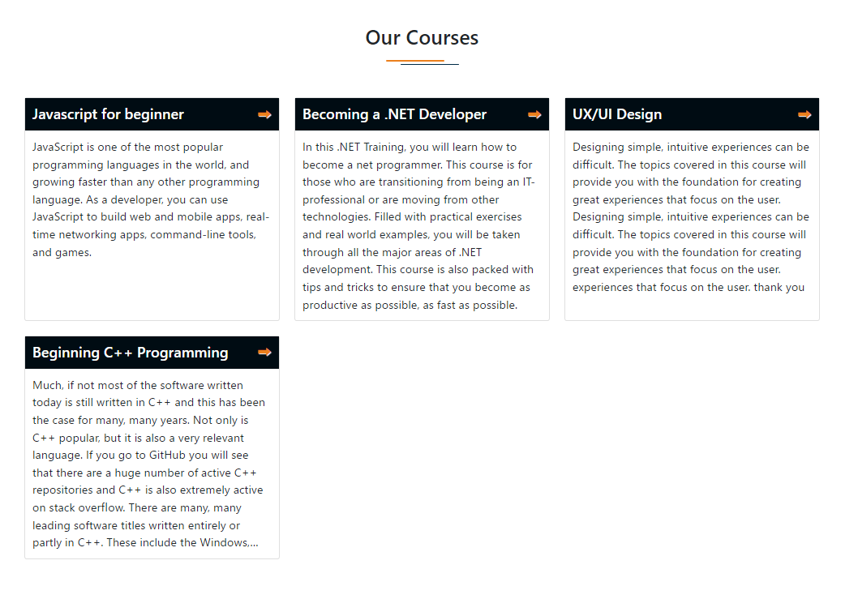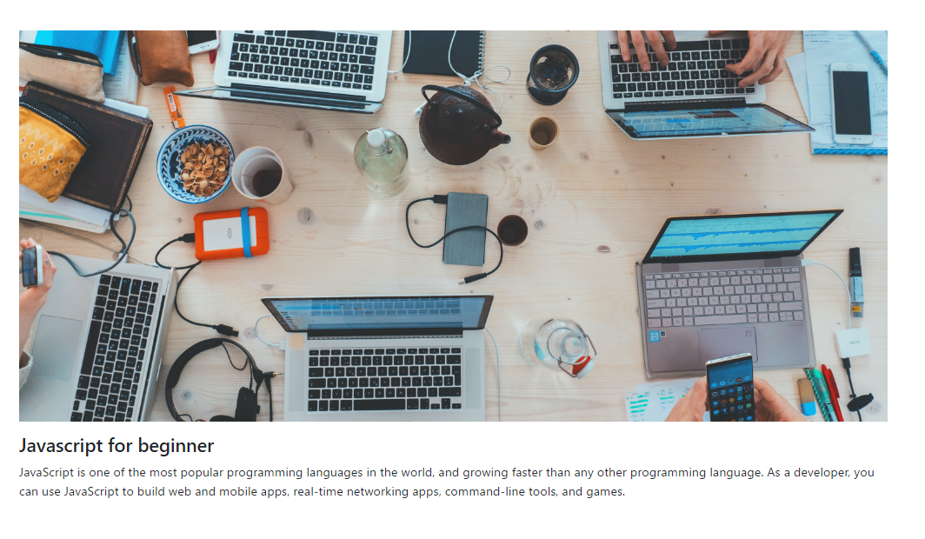

* **Purpose:** List the various courses offered and the topics covered
* **From:**  Header link, Home Page link
* **Description:** Data taken from Course table using API
* **Entrance Examinations**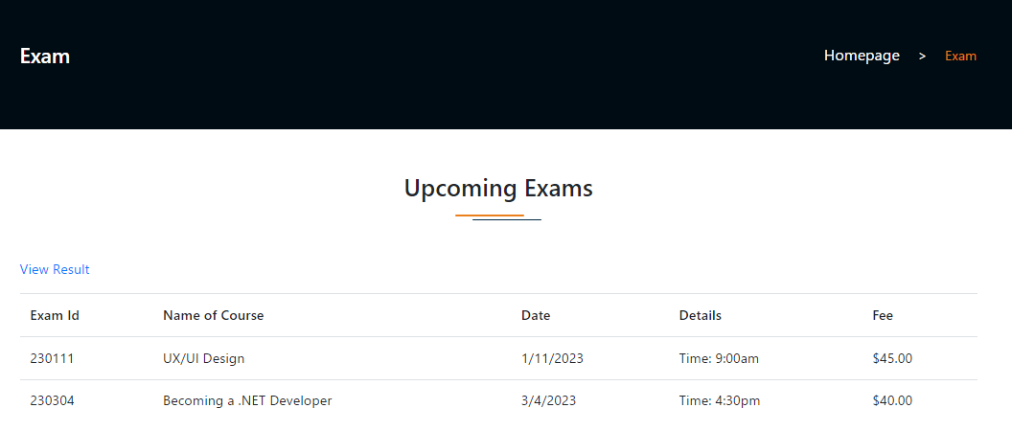
* **Purpose:** List the upcoming entrance examinations
* **From:** Header link
* **To:** Result of the last exam
* **Description:** Data taken from Exams table through API (filter upcoming exam that will be taking place after current date)
* **Entrance Examinations Result**

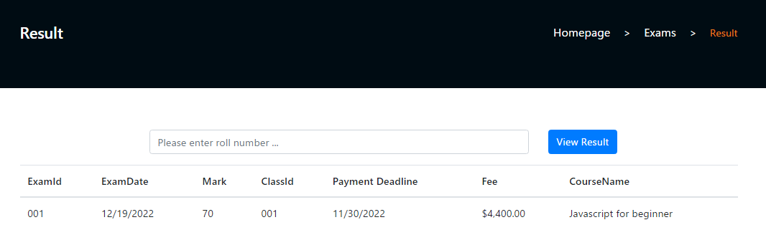

* **Purpose:** Show students’ result from the last entrance exam along with the class he/she is in and course fees with the last date for making the payment
* **From:**  Entrance Examinations list
* **Description:** Input students’ roll number to see result
* **FAQ’s**

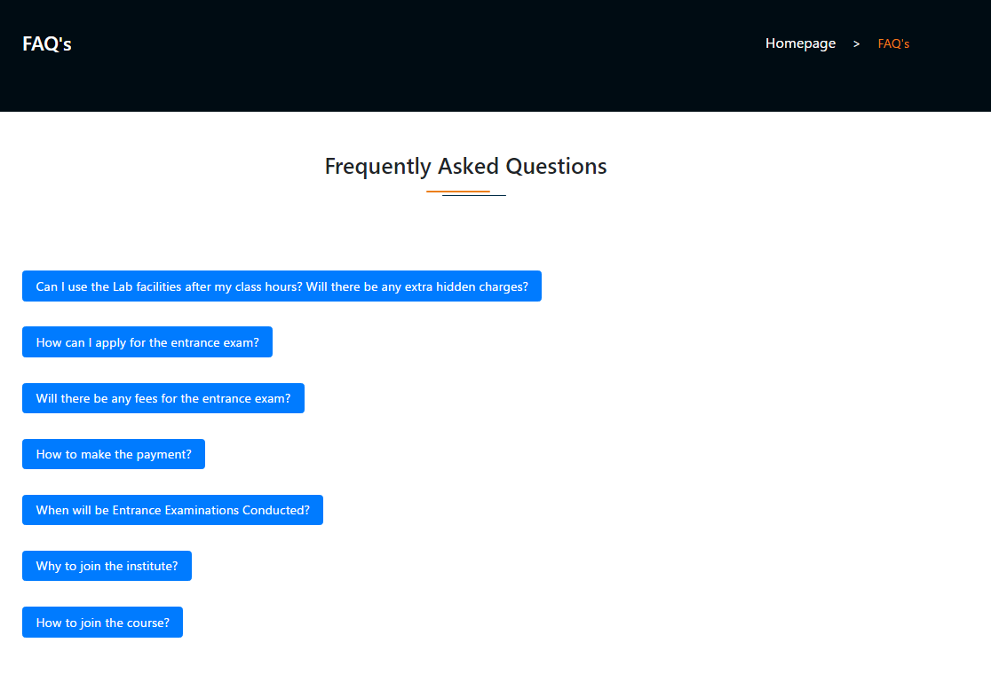

* **Purpose:** Show Frequently Asked Questions
* **From:** Header link
* **Description:**  Data taken from FAQ table through API
* **Contact Us (Centres)** 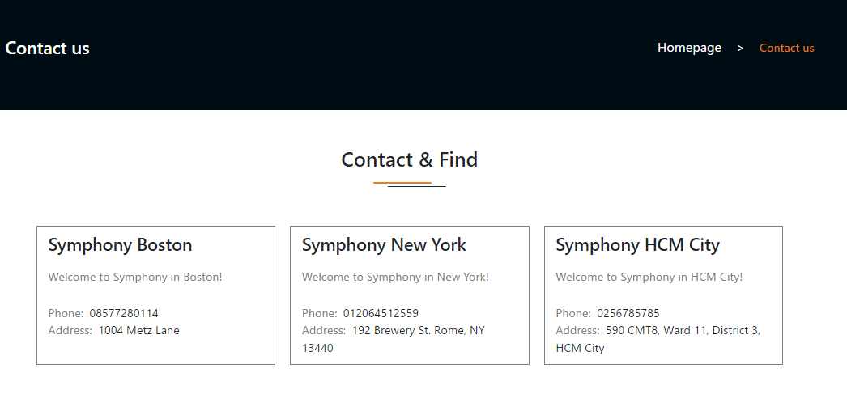
* **Purpose:** Show list of the various centres in different places
* **From:** Footer link
* **Description:** Data taken fromCentres table through API

### Admin

* **Login**

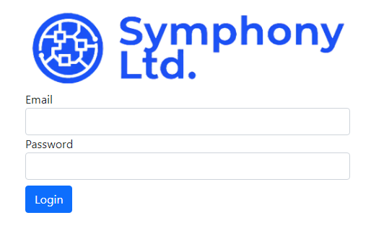

* **Purpose:** Login to the main page
* **From:** add “/admin” to normal site home page URL
* **To:** Admin site index
* **Description:** Send input to API and if valid, will generate JWT (JSON Web Tokens) and send back to main app to save in cookie. When using other functionalities of the admin site, the JWT is required as header authorization to get certain data and post/delete any data
* **Sidebar**

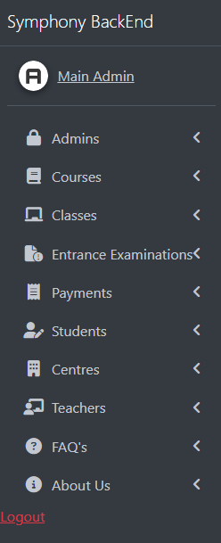

* **Purpose:** Link to other admin functionalities
* **From:** on the side of the admin site
* **To:** The admin functionalities
* **Description:** Side bar of website
* **Admin**

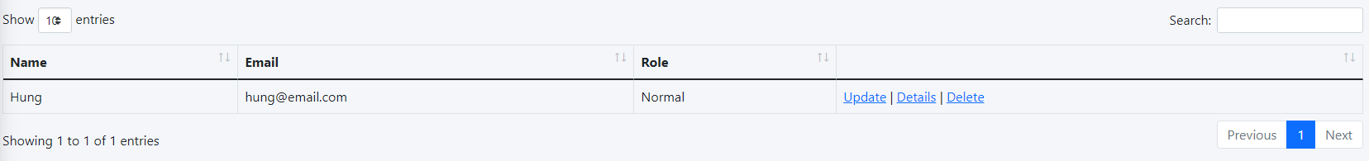

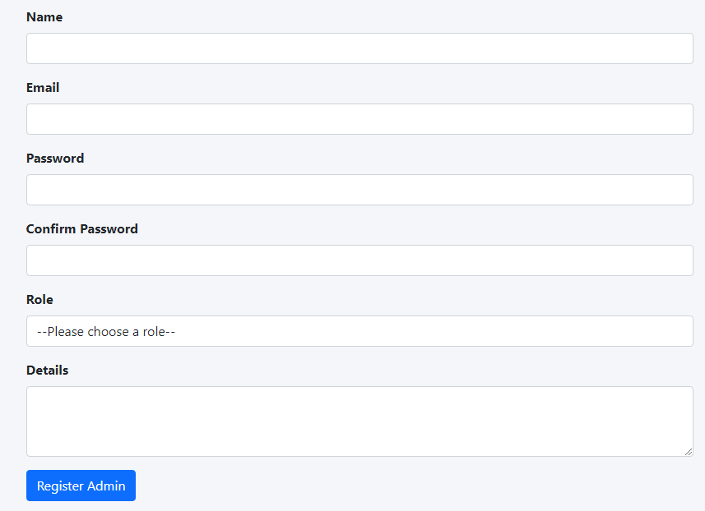 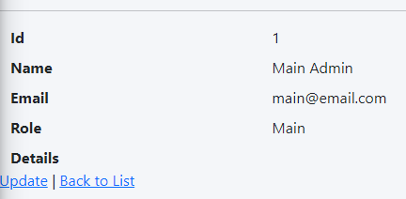

* **Purpose:** Admin Management
* **From:** Sidebar link
* **Description:** Take data from Admins table through API
* **Course** 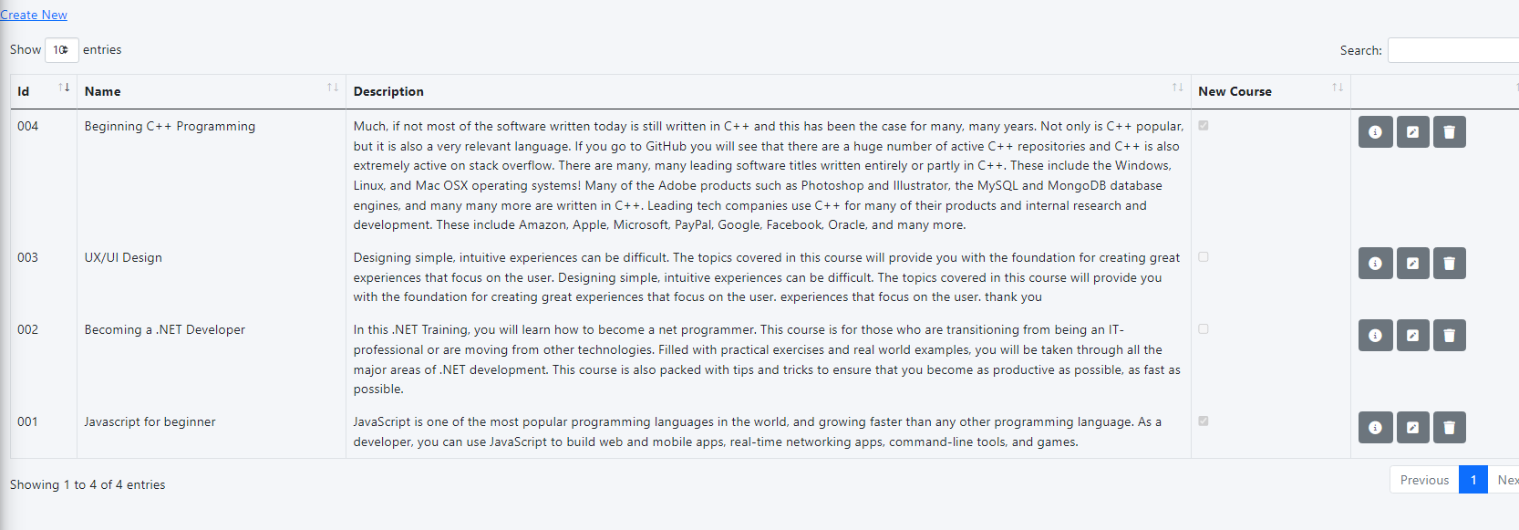
* **Purpose:** Course Management
* **From:** Sidebar link
* **Description:**  Take data from Courses table through API
* **Entrance Examinations** 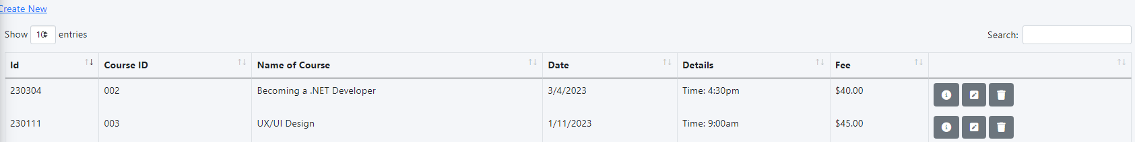
* **Purpose:** Entrance Exam Management
* **From:** Sidebar link
* **Description:**  Take data from Exams table through API
* **Student** 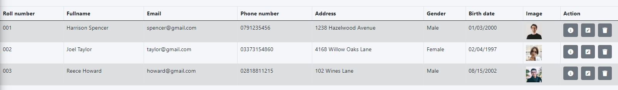
* **Purpose:** Student Management
* **From:** Sidebar link
* **Description:** Take data from Students table through API
* **FAQ** 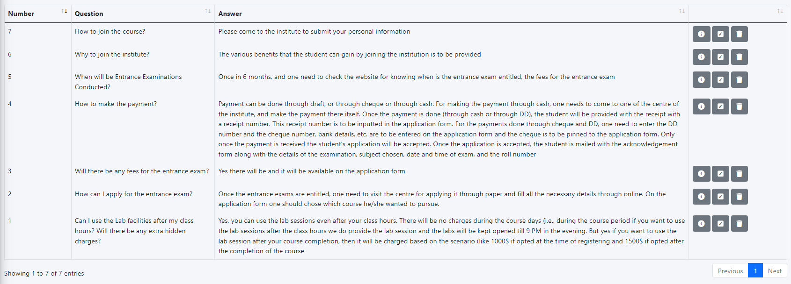
* **Purpose:** FAQ Management
* **From:** Sidebar link
* **Description:** Take data from FAQs table through API
* **Centre** 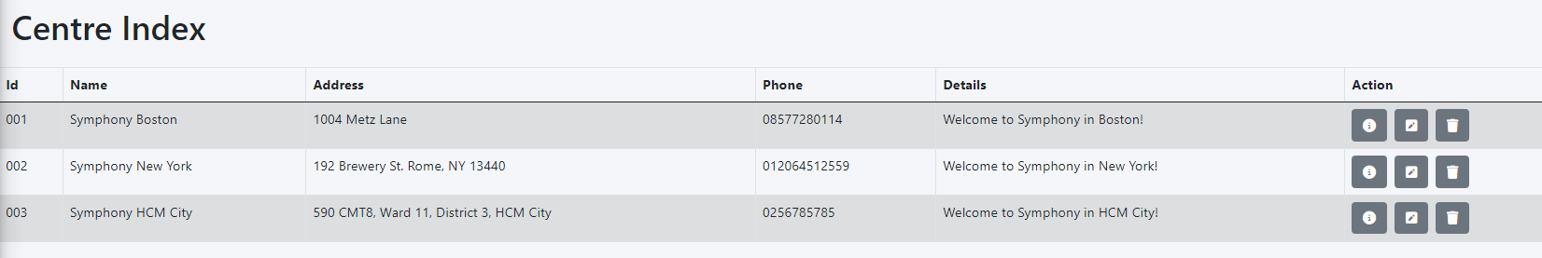
* **Purpose:** Centres Management
* **From:** Sidebar link
* **Description:** Take data from Centres table through API
* **About** 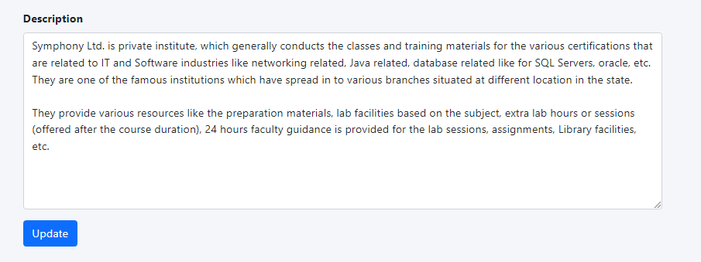
* **Purpose:** Enter or update the information about the institution
* **From:** Sidebar link
* **Description:** Data from About table through API
* **Payment**
* **Purpose:** Payment Management
* **From:** Sidebar link
* **Description:** Take data from Payments table through API
* **Teacher**
* **Purpose:** Teacher Management
* **From:** Sidebar link
* **Description:** Take data from Teacher table through API

# Task Sheet Review 3

|  |  |  |  |  |  |
| --- | --- | --- | --- | --- | --- |
| **Members Group** | | **Date Preparation of Activity Plan** | | | |
| **No** | **Name** | **Description Task** | **Start Date** | **End Date** | **Status** |
| 1 | Đào Bùi Quang Hưng | Admin (Login/Logout/Authenticate/Management)  Courses API  Exams (App + API)  Exam Result show  Payment (App + API) | 17/12/2022 | 28/12/2022 | Completed |
| 2 | Mai Quốc Tuấn | FAQ (API + App)  About Us (API + App) | 17/12/2022 | 28/12/2022 | Completed |
| 3 | Lê Quốc Trung | Student (API + App)  Teacher (API + App)  Centre (API + App)  Course (normal site view)  Home Page | 17/12/2022 | 28/12/2022 | Completed |
|  | | | | | |
| **Teacher** | | | **Team Leader** | | |
|  | | |  | | |
| **Nguyễn Kim Thuần** | | | **Đào Bùi Quang Hưng** | | |